**University of Westminster**

**Informatics Institute of Technology**

**6MARK017W– Digital Marketing, Social Media and Web Analytics**

**B.Sc. Business Information Systems**

INDIVIDUAL COURSEWORK 02

**Module Leader:** Mr. Prassanna Pathmanathan

**Student:** Mecci Nassim

(w1837024/20200824)

Date: 15/04/2024

Word Count: 2679

Table of Contents

**Task 1** 4

**1.1 Definition of GA4 Events** 4

**1.2 Function and Role of Events in GA4** 4

**1.3 Event Properties and User Interactions** 4

**1.4 Case-Study: Using GA4 Events on a Microsite** 5

**Task 2** 6

**Task 3** 8

**3.1 Definition of HTTP Cookies** 8

**3.2 Cookies relationship to the stateless web** 8

**3.3 Limitation of the cookies** 8

**3.4 what problem is overcome by cookies.** 9

**3.5 Diagram to illustrate data flow between web clients and servers when HTTP cookies are in use.** 9

**Task 4** 10

**4.1. Users by browser over time** 10

**4.2. Views by Page title and screen class over time** 11

**4.3. Sessions by ‘session default channel grouping’** 12

**4.4. New users by ‘First user default channel grouping’** 12

**4.5. User Engagement (overview)** 13

**4.6. User Retention (overview)** 14

**4.7. Users by City** 15

**4.8. Returning users by device category** 15

**4.9. New Users by Screen resolution** 16

**Task 5** 17

**5. 1 KPI Stated** 17

**5.2 Justification of KPI Based on Research or Analysis from TASK 4** 17

**5.3 All KPI Sections are Fully Defined with Appropriate Values** 17

**5.4 Appropriate Justification for Each Section of the KPI** 18

**Task 6** 18

**6.1 Email for Email Marketing Campaign.** 18

**Task 7** 20

**7.1 Challenges Related to the Calculation of Unique Visitors** 20

**7.2 Differences Between "Visitors," "New Visitors," and "Unique Visitors"** 20

**7.4 Challenges Associated with Measuring Session Duration and Web Page Time** 21

**7.4 The "Hotel Problem" in Web Analytics** 21

**7.5 Other Problems Related to Data Misinterpretation in Web Analytics** 21

Table Of Figures

Figure 1- Microsite Event Analysis 5

Figure 2- GA4 Account Creation 6

Figure 3- GA4 Data Stream Setup 6

Figure 4- Measurement ID Generation 7

Figure 5- GA Microsite Activation 7

Figure 6 Data flow diagram when cookies are in use -- (Source: HTTP Cookie, 2020) 9

Figure 7- Users by browser over time. 10

Figure 8- Views by Page title and screen class over time. 11

Figure 9- Sessions by ‘session default channel grouping.’ 12

Figure 10- New users by ‘First user default channel grouping.’ 12

Figure 11- User Engagement (overview) 13

Figure 12- User Retention (overview) 14

Figure 13- Users by City 15

Figure 14- Returning users by device category 15

Figure 15- New Users by Screen resolution. 16

Figure 16- Returning User Rate 17

Figure 17- Email Marketing Registration 18

Figure 18- Email Marketing Campaign 19

# **Task 1**

**1.1 Definition of GA4 Events**

“Events" plays a vital role in tracking and analyzing how users interact with a website In Google Analytics 4 (GA4). Page views, button clicks, form submissions, or any custom interaction a site owner thinks significant. Event count is the number of times events have been collected by Google analytics (Mangold, n.d).

Events in GA4 can be broadly categorized into:

* Automatically Collected Events-: These are tracked by GA4 without any additional setup, for example, page views, sessions start, and user engagement.
* Enhanced Measurement Events-: Enabled through the GA4 interface, these include interactions like scroll depth, outbound clicks, site search, and video engagement.
* Recommended Events-: These are predefined by Google based on best practices for specific industries.
* Custom Events-: These are defined by the website owners to track interactions unique to their specific needs.

**1.2 Function and Role of Events in GA4**

Events are fundamental in GA4 because they provide the information needed to understand user behavior as events in GA4 serve to collect and report on actions taken. By tracking these events, GA4 helps businesses measure the effectiveness of their content and user interface (Google, 2023). Events can also activate conversions or be part of a conversion path, therefore providing insights into user journeys and helping improve marketing strategies.

**1.3 Event Properties and User Interactions**

In Google Analytics 4 (GA4), event properties play a crucial role in gathering data from websites or apps. These properties provide additional context to events, allowing for a deeper understanding of user actions and more effective data interpretation. These parameters can include:

* Event name: Identifies the action taken by the user.
* Event category: Groups events into broader categories (e.g., engagement, navigation).
* Event label: Provides more detailed information about the event (e.g., video titles, download names).
* Event value: Assigns a numerical value to an event for quantitative analysis.

Custom parameters can also be defined to capture specific data relevant to a particular business or interaction model. By analyzing these properties, site owners can understand not just that an event occurred, but the context and specifics of the interaction, allowing for deeper analysis and more targeted improvements.

**1.4 Case-Study: Using GA4 Events on a Microsite**

The below (Figure 1) shows the engagement analysis based on the name and count of the event. By analyzing Event “Click” was counted as 62 when comparing the “Page view” Event of 788 which needs attention on checking the possibility to increase more Clicks to the site to gain more interaction.

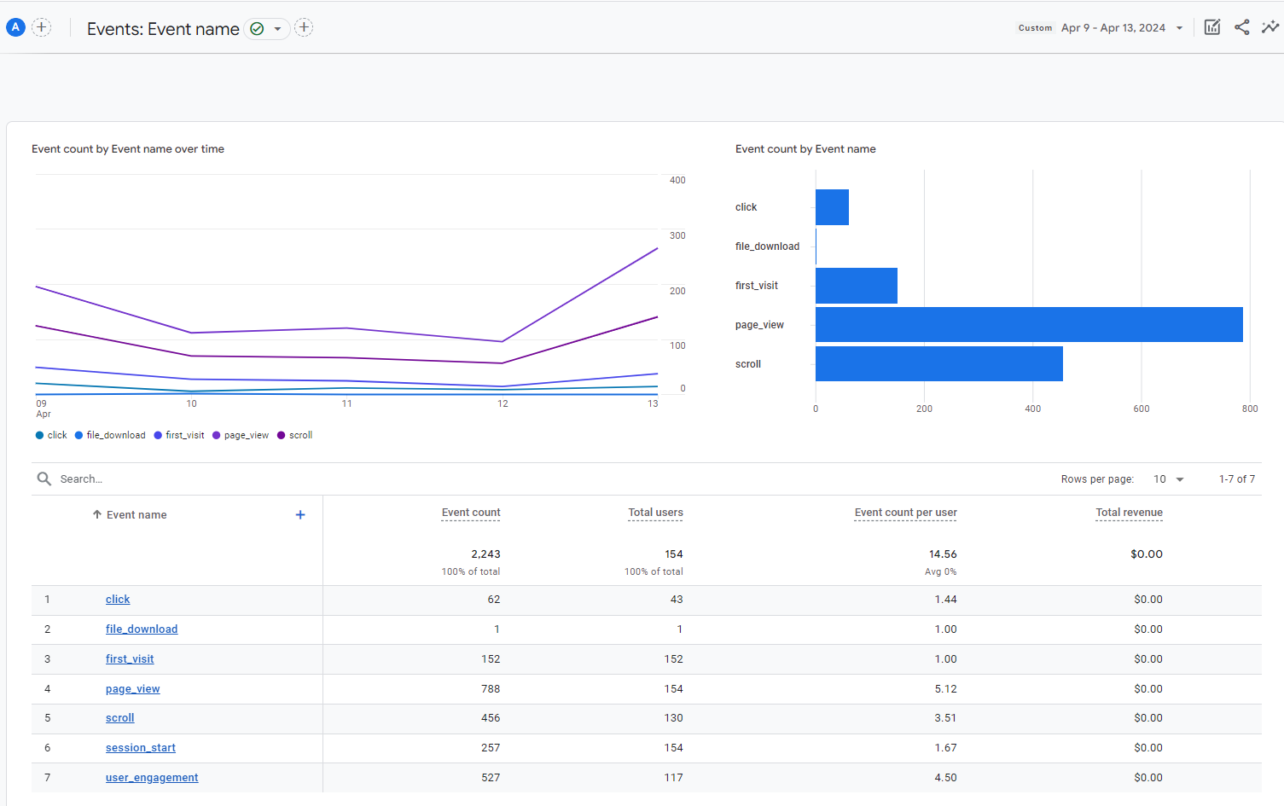

Figure 1- Microsite Event Analysis

By configuring GA4 to track these events, the microsite owner can extract actionable insights about user engagement, content preferences, and interaction patterns. This data is crucial for refining content strategy, improving user experience, and driving the site's key objectives.

# **Task 2**

First, Visited Google analytics using - www.google.com/analytics and login to Google analytics using the IIT email account. Follow the below steps to create the Google analytics ID for the microsite,

**Step 1 –:** Create the Google Analytics accounts by adding necessary details.

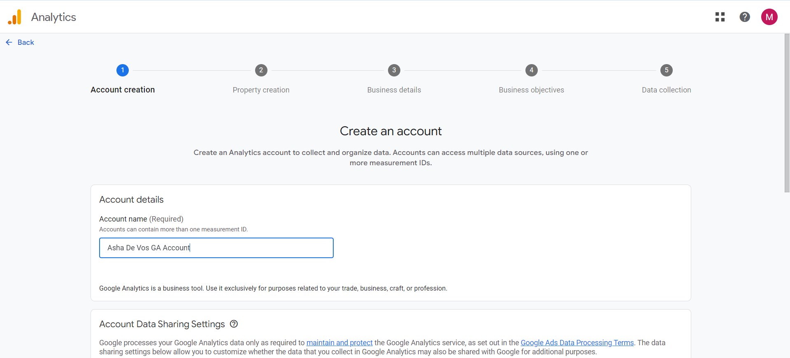

Figure 2- GA4 Account Creation

**Step 2 -:** Setting up the data stream, Selected the option ‘web’ and inserted the URL to the microsite and Stream name.

Figure 3- GA4 Data Stream Setup

**Step 3 –:** Generate the web stream data to Generate the Measurement ID.

Stream Name: Asha De Vos | Measurement ID: **G -9K42H6WQFX**

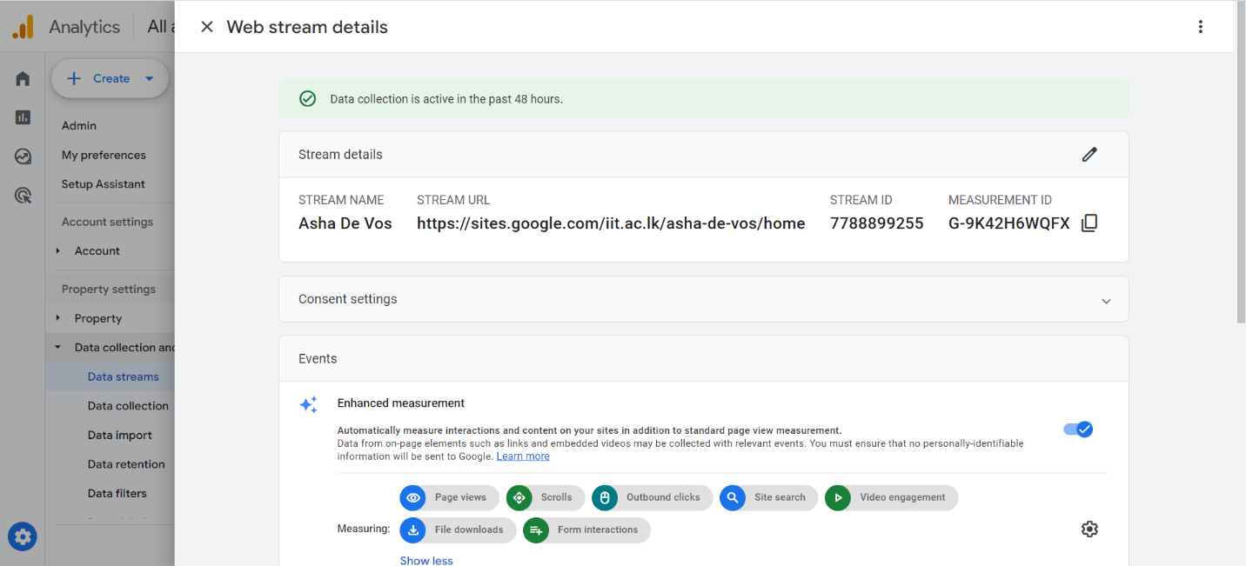

Figure 4- Measurement ID Generation

**Step 4 –:** Inserts the generated measurement ID in the created google site analytics page and enables analytics.

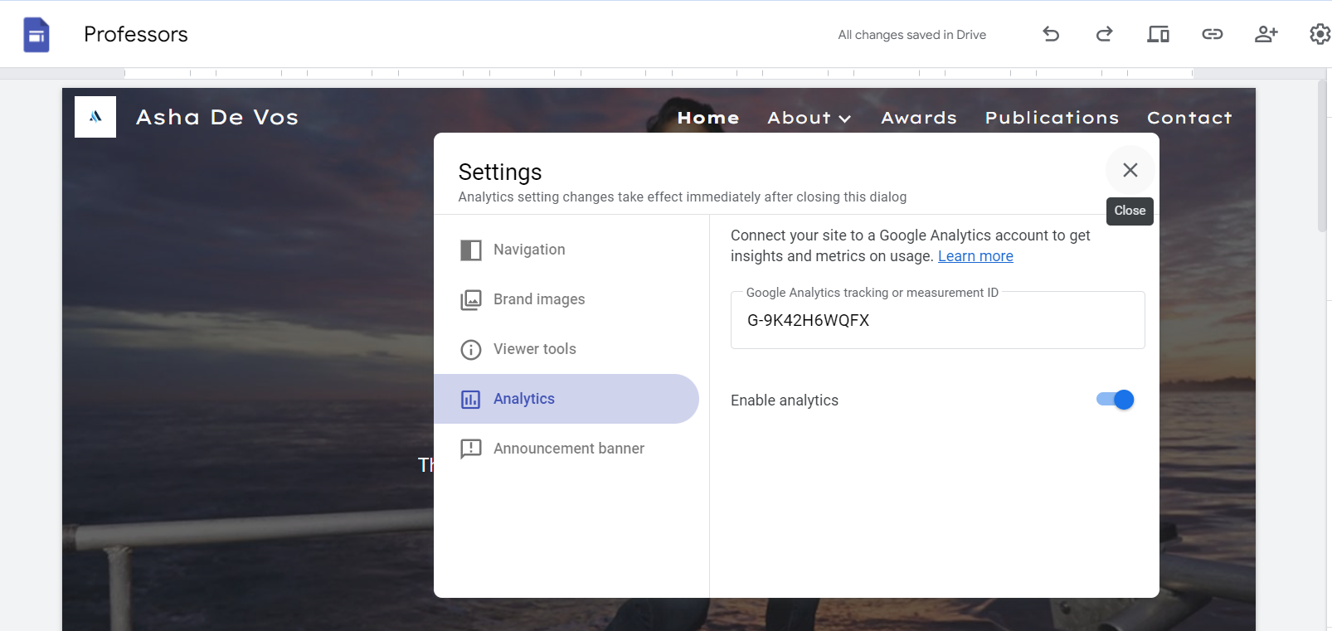

Figure 5- GA Microsite Activation

By following the above 4 steps I was able to create and publish the account.

# **Task 3**

**3.1 Definition of HTTP Cookies**  
HTTP cookies are small text files that a web server sends to a user's browser, which are stored on the user's device (Kaspersky, 2024). These cookies are sent back to the server with following requests from the browser. Cookies are created when a user visits a website for the first time, followed by a short stream of data originated from the web server to identify your information to the web browser. They are used to maintain stateful information for the user's session, enabling continuity of user-specific settings and login states across different pages of a website (arvindpdmn, 2020).

**3.2 Cookies relationship to the stateless web**

When it comes to managing user interactions with stateless web protocols such as HTTP, cookies are essential. Each user request is handled independently by HTTP because it does not automatically remember previous interactions. Therefore, tasks like user authentication and maintaining the contents of shopping carts are more difficult. Cookies help servers to remember specific user information for later interactions by saving it on the client side. As for cookies are essential for providing a more effective online experience and to maintain track of the stateful information for the stateless HTTP protocol (Cookies, 2022).

**3.3 Limitation of the cookies**

|  |  |
| --- | --- |
| Limitation | Description |
| Security Risks | Cookies are open to theft or interception. Using attributes like HTTP Only and Secure can mitigate some risks by blocking access. Additionally, not all websites that gather data through cookies are trustworthy (Raghuvanshi, n.d.). |
| Size and Storage Limits | Cookies have a size limit (typically up to about 4KB) and a limited number per domain, which limits how much data can be stored. |
| Performance Impact | Cookies are included in every HTTP request for a domain, which can increase load times and affect performance if the data is not efficiently managed as cookies will remain on the user's hard drive until they are deleted. This eventually causes the browser to lag or slow down (Roomi, 2021). |
| Privacy Concerns | Cookies can track user behavior across multiple sites, raising privacy issues. The majority of consumers are not aware that such data is kept on their hard drive. |

**3.4 what problem is overcome by cookies.**

The main problem that cookies address is the statelessness of the HTTP protocol. HTTP, by design, does not maintain state information between different requests made by the same user. The browser will not be as efficient or customized between questions because the server cannot remember the user's session or preferences. Cookies help solve this by allowing servers to store user data directly on the client's browser, which the browser then sends back to the server with each request. This way, the server can recognize returning users and restore their session state (HTTPCookie , 2020). Therefore, cookies enable a website to remember a user's preferences and maintain a constant state across successive requests even though HTTP is a stateless protocol (Chan, 2021).

**3.5 Diagram to illustrate data flow between web clients and servers when HTTP cookies are in use.**

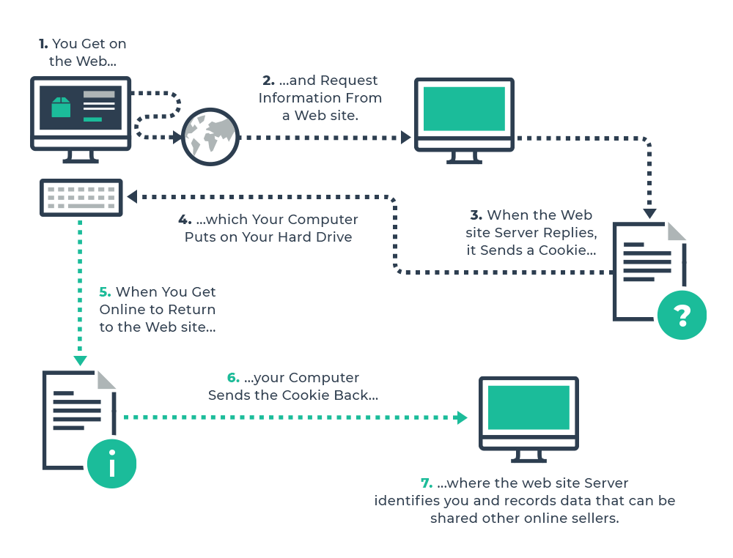

Figure 6 Data flow diagram when cookies are in use -- (Source: HTTP Cookie, 2020)

# **Task 4**

The website's activity was monitored for 5 days between April 9th and April 13th, 2024, to finish this task. A total of 154 users visited the site during this period and the results are as follows.

**4.1. Users by browser over time**

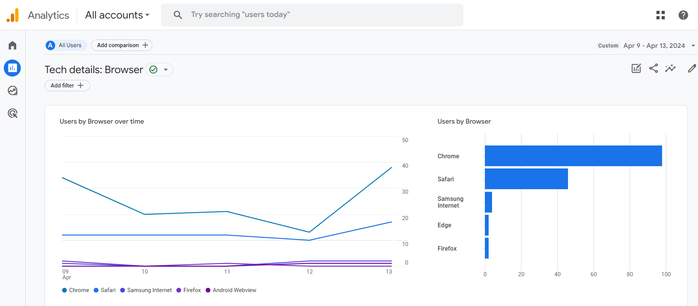

Figure 7- Users by browser over time.

This study examines the browser-specific user behavior over time. Chrome is the most widely used browser 98 users, followed by Safari with 46 users. Firefox and Edge have the same rate of engagement of all browsers, but users who have used Firefox were more likely to interact with the website and spend more time on the website during their session with highest session average engagement time of 1m 22seconds. Therefore, inconclusion safari browser is more convenient to use for iOS users and Google Chrome is a more user-friendly browser overall user.

The browser provides insight into the technologies used by visitors who may become potential customers. It also informs about the top browsers, which browsers are popular and most used, the number of sessions in those browsers, and so on (scubeco, 2021)

**4.2. Views by Page title and screen class over time**

Figure 8- Views by Page title and screen class over time.

The key Highlights and recommendations based on analysis is the most viewed web page is the Home page with 323 followed by the contact page of 154 views. Awards, Publications, about page and Oceanswell page following up. As for the analysis, the high event count rate and time spent on the home page indicates that the page is engaging is more user friendly and as it’s the landing page. As the engagement rate is low it’s better to optimize all pages for better user engagement and for websites overall performance. This calculates browsing time spent on a website and considers only when a user browses through the while site (Arora, 2022). The calculation is as follows.

* 𝐴𝑣𝑒𝑟𝑎𝑔𝑒 𝑒𝑛𝑔𝑎𝑔𝑒𝑚𝑒𝑛𝑡 𝑡𝑖𝑚𝑒/A𝑐𝑡𝑖𝑣𝑒 𝑢𝑠𝑒𝑟

As the engagement rate is low it’s better to optimize all pages for better user engagement and for websites overall performance.

**4.3. Sessions by ‘session default channel grouping’**

Figure 9- Sessions by ‘session default channel grouping.’

The analysis focuses on three social media channels: Direct, Unassigned, and Organic. The report shows how most of the users accessed through a direct link which is 149 while the remaining accessed through organic Search.

Social media and email campaigns, re-aligning marketing strategies, optimizing back links are some of the ways this goal can be achieved.

**4.4. New users by ‘First user default channel grouping’**

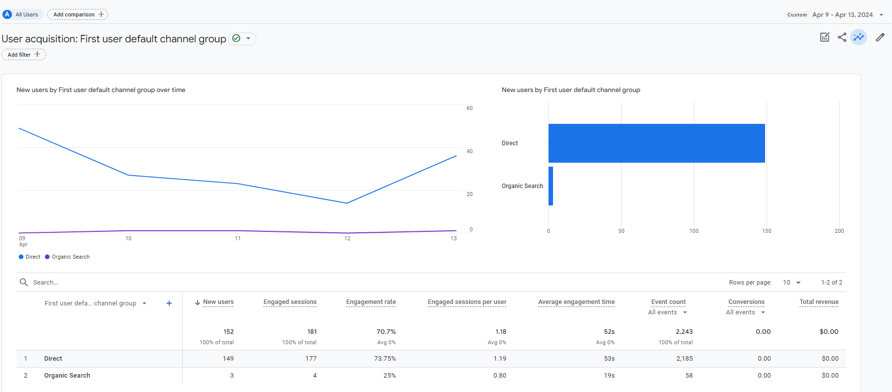

Figure 10- New users by ‘First user default channel grouping.’

In GA4, New user is measured by considering the number of unique id’s that first log in to the system. A new user is an individual that has never visited the website before or is interacting with the system for the first time (mixpanel, 2020). Therefore, most of the new users (149 out of 152) have been directed to the website directly through the links shared on emails and WhatsApp. The 3 other users found the website through an organic search. The engagement rate recorded for new users is 73.75%, which indicates that the website's content has caught the interest of the new users.

**4.5. User Engagement (overview)**

Figure 11- User Engagement (overview)

The User engagement overview shows that, on average, users spend 52s on my website, engaged session per user 1.2 and time per session was 31s. The Formulas to calculate for user engagement overview are as follows.

* 𝐴𝑣𝑒𝑟𝑎𝑔𝑒 𝐸𝑛𝑔𝑎𝑔𝑒𝑚𝑒𝑛𝑡 𝑇𝑖𝑚𝑒 = 𝐸𝑛𝑔𝑎𝑔𝑒𝑚𝑒𝑛𝑡 𝑇𝑖𝑚𝑒 / 𝐴𝑐𝑡𝑖𝑣𝑒 𝑈𝑠𝑒𝑟𝑠
* 𝐸𝑛𝑔𝑎𝑔𝑒𝑑 𝑆𝑒𝑠𝑠𝑖𝑜𝑛 𝑃𝑒𝑟 𝑈𝑠𝑒𝑟 = 𝑁𝑜.𝑜𝑓 𝑒𝑛𝑔𝑎𝑔𝑒𝑑 𝑠𝑒𝑠𝑠𝑖𝑜𝑛𝑠 / 𝑇𝑜𝑡𝑎𝑙 𝑈𝑠𝑒𝑟 𝐴𝑣𝑒𝑟𝑎𝑔𝑒
* 𝐸𝑛𝑔𝑎𝑔𝑒𝑚𝑒𝑛𝑡 𝑇𝑖𝑚𝑒 𝑃𝑒𝑟 𝑆𝑒𝑠𝑠𝑖𝑜𝑛= 𝐸𝑛𝑔𝑎𝑔𝑒𝑚𝑒𝑛𝑡 𝑇𝑖𝑚𝑒 / 𝑆𝑒𝑠𝑠𝑖𝑜𝑛𝑠

The average engagement time decreased between April 9 and April 10, possibly as a result of repeat visits by the same users. To overcome this implementing social media and SEO strategies will help draw in new users to reverse this trend and maintain user engagement.

**4.6. User Retention (overview)**

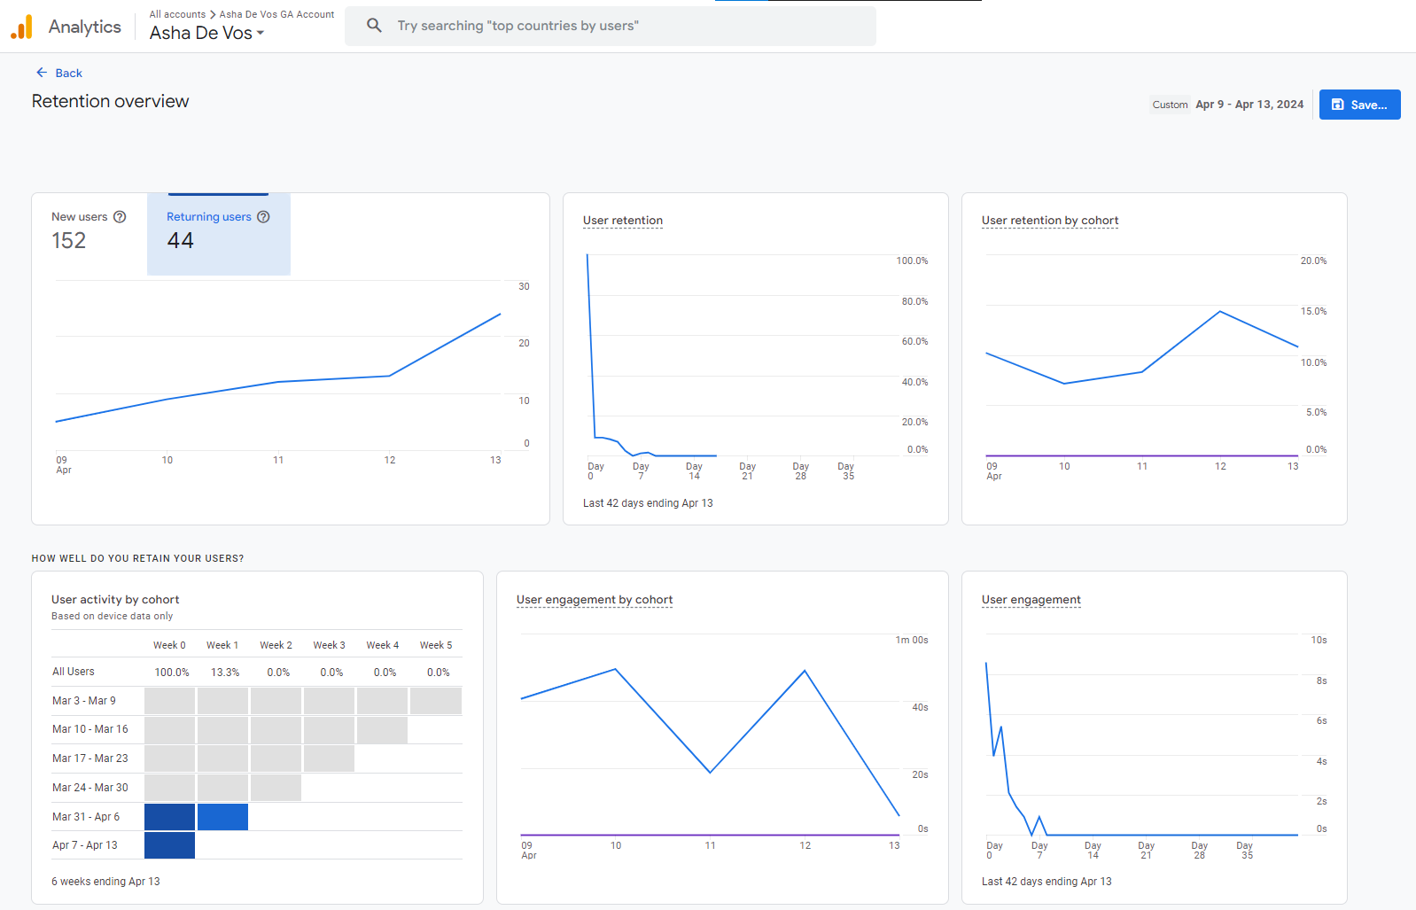

Figure 12- User Retention (overview)

This analysis section demonstrates how devoted website users are. 44 user retention out of 152 users are a somewhat significant retention to the page. It also shows the evolution of these indicators through time. This aids in understanding how frequently and for how long users return to your website. Despite a minor increase in repeat user interaction over time, the user experience can be improved to attract more users to utilize the website more frequently. The most recent cohort of users had the lowest retention rate, according to the study on user retention by cohort. This could signal that to maintain user engagement, issues with the website or the onboarding procedure need to be resolved.

**4.7. Users by City**

Figure 13- Users by City

While checking usage analysis by cities 101 out of 154 users are 71% of users have accessed to the website from Colombo and other cities such as Waligama, Galle (Local) and Delhi (Foreign) has a small number of users throughout the timeframe. To better understand the audience and target marketing campaigns, demographic data from sources, such as Google data, device data is used to create segments based on attributes such as age, gender, and geographic location (Jacobsen, 2023).

**4.8. Returning users by device category**

Figure 14- Returning users by device category

This analysis displays the number of returning visitors who came to your website using various device types. While analyzing the most popular devices among returning users are mobile phones which is 36 which is a sizable portion 68%. Desktops were also used by 8 repeat visitors.

**4.9. New Users by Screen resolution**

Figure 15- New Users by Screen resolution.

GA4 screen resolution from all the site visitors and displays it in a report to analyze problematic screen resolutions and browser sizes. The report generated for screen resolution denoted the users, engaged sessions, and events, out of which, highest engagement was found in 1536 x 864,390 x 844, 393 x 873, etc. Screen resolution is measured by pixels and is referred to the hardware of the device and is measured by GA4 to promote understanding about the importance of design, development, analytics, and conversion rate optimization (Vanhee, 2023).

# **Task 5**

**5. 1 KPI Stated**

KPI: Repeat User Growth Rate

**5.2 Justification of KPI Based on Research or Analysis from TASK 4**

The data indicated in GA4 is that while there is a reasonable user retention rate with some users returning to the site, there's a noted drop in engagement over time. Based balanced scorecard approach (BSA) of Finance, Customer, Internal Process and Growth, KPI should be addressed (LTS, 2023). By analyzing the microsite to ensure maintain growth of the microsite, it's critical to increase the number of users who return after their initial visit as the KPI. Which is due to only 44 users returning out of 152 as (figure 16) shows.



Figure 16- Returning User Rate

**5.3 All KPI Sections are Fully Defined with Appropriate Values**

* Focus: Repeat User Growth Rate is the percentage increase in the number of returning users over a specific period.
* Target Value: Aim for a 10% month-over-month increase in returning users.
* Data Source: User retention and engagement metrics from Google Analytics 4.
* Reporting Frequency: The KPI will be evaluated on a monthly basis.

**5.4 Appropriate Justification for Each Section of the KPI**

**Focus-:** Focusing on the growth rate of repeat users is essential given that the user retention reports showed a significant initial retention but a need for better user engagement plans.

**Target Value -:** A 10% growth target is possible with the right engagement strategies, such as improved content, user experience and marketing.

**Data Source -:** GA4 provides consistent tracking and is already integrated into the microsite, making it the best tool for monitoring this KPI.

**Reporting Frequency -:** Monthly tracking aligns with typical marketing cycles, allowing enough time to assess the impact of changes implemented based on the KPI.

# **Task 6**

**6.1 Email for Email Marketing Campaign.**

The email (Figure 18) is created based for the KPI: Repeat User Growth Rate of Task 5. The email will be initially shared across the subscribed 79 users (Figure 17) as Email Marketing campaign to the microsite to increase user returning.

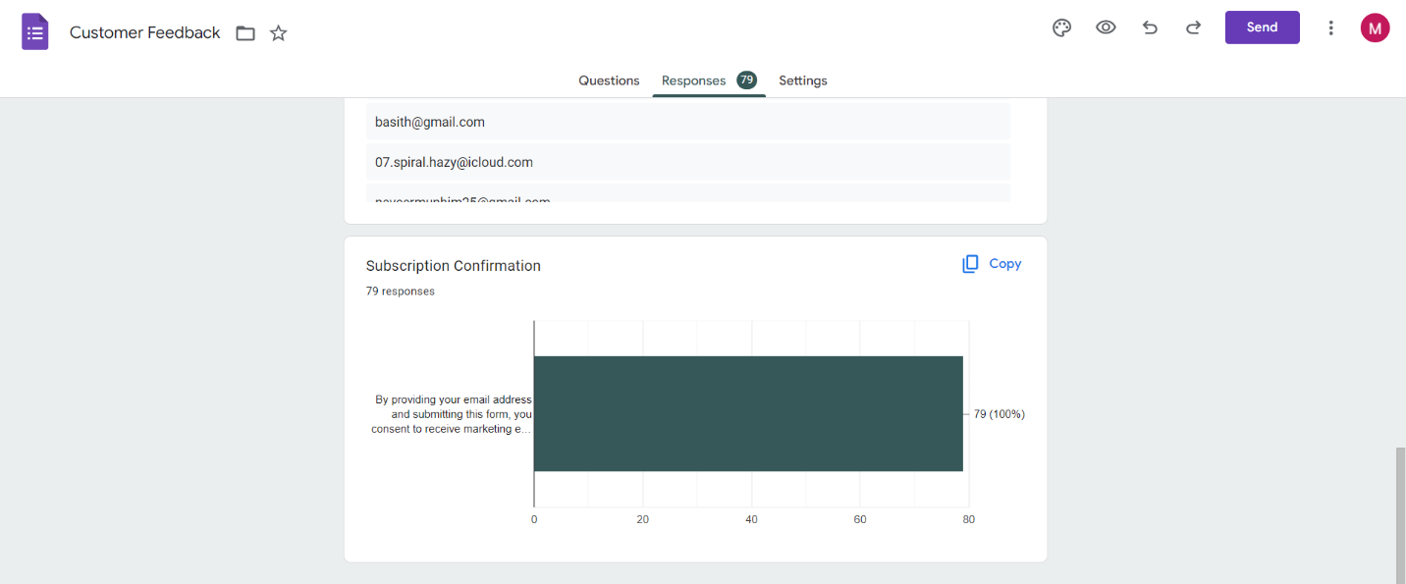

Figure 17- Email Marketing Registration



3 Call-To-Action Button

Body

(Description & Images)

Footer

(Subscribe & Unsubscribe Action)

Heade

(Logo & Title)

Figure 18- Email Marketing Campaign

# **Task 7**

**7.1 Challenges Related to the Calculation of Unique Visitors**

One main challenge in web analytics is accurately counting unique visitors. A unique visitor is counted once within a given time regardless of how many times, they visit the site (Liz, 2021). These are factors complicate this calculation:

* Cookie Deletion and Blocking
* Use of Multiple Devices
* Privacy Regulations

**7.2 Differences Between "Visitors," "New Visitors," and "Unique Visitors"**

|  |  |  |
| --- | --- | --- |
| Term | Definition | Potential Misinterpretation |
| Visitors | Total number of visits to the site, including repeat visits. | May be mistaken with unique users; doesn't indicate newness. |
| New Visitors | Individuals visiting the site for the first time in each tracking period. | Mistaken if cookies are reset or devices are changed. |
| Unique Visitors | Visitors to the site during a specified period, counted once. | Miscalculated if users visit from multiple devices. |

**7.4 Challenges Associated with Measuring Session Duration and Web Page Time**

Accurately measuring how long a user spends on a website or a specific page presents several technical challenges:

Single Page Visits: If a user leaves a website from the same page they landed on without interactions that the analytics can track, the session duration is often recorded as zero.

Background Tabs: Users often open tabs and leave them running in the background, which can either lead to underestimation or overestimation of session times.

User Inactivity: Determining when a user is actually interacting with the site versus leaving a page open without engagement is complex.

Accurate Time Measurement: Traditional analytics tools rely on the time stamps of page loads and interactions, which may not precisely reflect user engagement.

**7.4 The "Hotel Problem" in Web Analytics**

The "hotel problem" is an analogy used to describe the issues with average session duration metrics in web analytics. If one imagines a hotel where every room is occupied each night (each visitor visits only one web page and then leaves), the average stay per visitor would be one day, regardless of the number of rooms or visitors (Lynchpin, 2015). Similarly, if every visitor to a website visits several pages but all only once per session, it would appear that each visitor's engagement is very low even if the overall engagement across the site is high. This problem highlights the limitation of average metrics in understanding individual user engagement.

**7.5 Other Problems Related to Data Misinterpretation in Web Analytics**

* Bounce Rate Confusion: High bounce rates are typically seen as negative.
* Traffic Source Attribution: Properly attributing traffic to the correct source can be difficult (e.g., direct, organic search, referral).
* Cross-Device Tracking Issues: Users might start a session on one device and continue another.
* Conversion Tracking: What action or page truly influenced a conversion can led to misled decisions.